Elephants shuttle to thermoregulate

Maria Thaker1*, Pratik R. Gupte1,2, Herbert T. Prins3, Rob Slotow4, Abi T. Vanak2

1Centre for Ecological Sciences, Indian Institute of Science, Bangalore, India

2Ashoka Trust for Research in Ecology and the Environment, Bangalore, India

3Wageningen University and Research (Alterra), Wageningen, The Netherlands

4University of Kwa-Zulu Natal, Durban, South Africa

**\* Correspondence:**Maria Thaker  
[mthaker@iisc.ac.in](mailto:mthaker@iisc.ac.in)

Keywords: African elephant *Loxodonta africana*1, thermoregulation2, GPS telemetry3, recursion analysis4, temperature loggers5.

Abstract

Overheating is a major concern for large mammals, and many species must make decisions about whether and where to move to avoid thermal stress. The movements of savanna elephants *Loxodonta africana* have received much attention in the context of water dependence, yet ambient temperature has seldom been invoked to explain them. We tracked 14 herds of elephants in Kruger National Park, South Africa using GPS collars over a period of 2 years. We first quantified temperature differences between the landscape types traversed by elephants, and confirmed that temperature loggers (thermochrons) built into the GPS collars accurately reported ambient temperatures. We then identified elephant visits to water, and studied elephant movement between successive visits to water-sources.

We found that elephants in Kruger have characteristic intervals of visits to water that follow the diurnal cycle. Elephants making day-long forays away from a water source are site-faithful, returning to within a kilometre of the same source nearly half the time within a 24 hour period. Elephants are closest to water during the hottest parts of the day, and move away from water as temperatures fall. In contrast with other savanna ungulates, elephants move at their highest speeds as they approach and leave water, and move at their slowest during the night. Temperature drives the relationship between speed and distance to water, with elephants moving nearly twice as fast at upper temperature extremes than at the daily mean temperature. These findings have implications for management that seeks to control elephant ranges by altering the distribution of water sources.

# Introduction

Animals faced with heat stress thermoregulate by altering their physiology and behaviour (Angilletta 2012). Most physiological responses to high temperatures, such as sweating in mammals, rely on water evaporation to transfer heat away from the core-body. Many animals must complement physiological thermoregulation with behavioural mechanisms of losing heat. In general, behavioural responses to overheating involve utilising heat-sinks to which excess body-heat may be transferred. For example, the large ears of savanna elephants *Loxodonta africana* aid in rapid cooling by offering a large surface area that readily loses heat to the environment (Wright 1984). Thermal stress may also be avoided by temporal changes in activity. Most desert dwelling mammals are nocturnal, yet even in milder climates, ibex *Capra ibex* and elephants shift their activity peaks to earlier in the day in the hot season (Aublet *et al.* 2009; Leggett 2010). Occupying landscapes that promote heat loss, such as water sources or shade under dense vegetation constitutes another important class of behavioural responses to heat stress. For example, moose *Alces alces* seek refuge from high temperatures in shady coniferous forests in summer (Beest et al. 2012), while Arabian oryx *Oryx leucoryx* select for covered sites during the hottest part of the day(Hetem *et al.* 2012). Some landscapes, such as water sources, may promote both behavioural and physiological thermoregulation, as water is both a direct heat sink as well as a critical resource for evaporative water loss. This allows large tropical herbivores such as Cape buffalo *Syncerus caffer* and elephants to wallow and drink at water sources to cool down(Bennitt *et al.* 2014; Purdon 2016).

Animals must balance the energetic benefits of using water as a thermoregulatory aid against the costs of negative interactions such as predation and competition at crowded waterholes(Cain *et al.* 2012; Owen-Smith and Goodall 2014). Individuals may attempt to avoid such costs by periodically shuttling between water and more optimal foraging and resting sites, but this increases movement costs and decreases time that could have been spent feeding(Johnson *et al.* 2002; Cain *et al.* 2012; Owen-Smith and Goodall 2014; Giotto *et al.* 2015). Body size may mediate how a species reckons with the costs and benefits of visiting water. Large species such as buffalo and eland *Taurotragus oryx* that overheat more quickly are likely to be more water-dependent than smaller ones such as sable antelope *Hippotragus niger,* and zebra *Equus quagga*(Cain *et al.* 2012; Shrestha *et al.* 2012; Bennitt *et al.* 2014; Owen-Smith and Goodall 2014). Water-dependence can introduce periodicity to an animal’s movement, such as that corresponding to the diel or seasonal cycle (Giotto *et al.* 2015). However, it is in turn affected by seasonal changes. For example, buffalo in the Okavango delta are found farther from permanent water sources in the hot-wet season when they can use ephemeral pools, and closer to water in the cool-dry season(Bennitt *et al.* 2014). Further, seasonal changes in temperature and resource availability can affect the activity and movement of ungulates, changing their distribution in relation to water(Leggett 2010; Shrestha *et al.* 2012; van Beest *et al.* 2012; Owen-Smith and Goodall 2014). This sets up an interaction between environmental conditions such as ambient temperature, an individual’s physiological state, and its position in relation to water sources.

Savanna elephants are an excellent study system to examine the effects of temperature on movement strategies in relation to water. Elephants lack a physiological means of thermoregulation, such as sweating or panting, and therefore compensate by using thermoregulatory behaviours, such as ear-flapping (Hiley 1975; Wright 1984; Wright and Luck 1984). At larger spatio-temporal scales, elephants avoid thermal stress and the energetic costs of thermoregulation by shifting their activity peaks to cooler times of the day, and select for thermally stable landscapes with lower variation in daily temperatures(Johnson *et al.* 2002; Kinahan *et al.* 2007; Leggett 2010). Elephants are also heavily water dependent and make periodic visits to water to hydrate and thermoregulate (Valls Fox 2015). Seasonal changes can have a significant effect on elephant movement, with individuals from populations in Namibia and South Africa moving faster in the wet season than the dry season, suggesting an effect of water availability on movement(Leggett 2010; Birkett *et al.* 2012). However, in both these cases, the wet and dry seasons overlap with the hot and cool seasons, respectively, opening up the possibility that differences in mean temperature between the seasons could contribute to differences in movement. Testing this hypothesis requires both high-resolution position and temperature data at each step of a movement track. Here, we characterise elephant movement in relation to water sources and ambient temperature using data from traditional satellite telemetry, coupled with instantaneous data from temperature loggers (thermochrons) borne by individuals, to test the hypothesis that savanna elephants’ movement is driven by temperature.

# Methods

## Data collection

The study was conducted in the predominantly semi-arid savanna landscape of Kruger National Park and adjacent private game reserves (extent: 31.06ºE – 32.0ºE, 23.9ºS – 25.4ºS) in South Africa, where we have had 14 female African elephants – each from a different herd – fitted with GPS logger-transmitter collars since 2007 (Fig. 1a, 1b). Details of the capture and collaring of these elephants, including an ethics and permissions statement can be found in Birkett *et al.* 2012. Collars on elephants had transmitters and inbuilt thermochrons that were set to record half-hourly position and temperature data, respectively. For this study, we selected location and temperature data from the 14 tagged elephants between August 2007 and August 2009, which we define as the study period, and during which each elephant was tracked for on average 637 days (range: 436 – 731 per elephant).

We obtained the following landscape-level data: (1) a map (shapefiles) of all rivers, the locations of active park waterholes, and 30m resolution terrain slope from Shuttle Radar Topography Mission V3 data (Farr *et al.* 2007); (2) polygon shapefiles of the landscape types of Kruger NP as defined by Gertenbach 1983; (3) satellite imagery of the study area taken in the low-gain thermal infrared range (Band 6 VCID 1: 10.40 – 12.50 μm) by the Enhanced Thematic Mapper + device aboard LANDSAT-7 over the study period, which we converted to degree Celsius temperature data (Chander *et al.* 2009); (4) satellite imagery of the study area from the same source as (3) taken in the red and near infrared ranges (Band 3 (red): 0.63 - 0.69 µm, and Band 4 (near infrared): 0.77 - 0.90 µm), from which we calculated a two-year mean normalised difference vegetation index (NDVI) for use as a mapping layer (see Fig. 2a) (Rouse Jr *et al.* 1974).

We also obtained ambient temperature data from the weather station tower at Kruger headquarters at Skukuza (24.98°S, 31.5°E) over the study period (Fig. 1b).

## Variation in temperature across the landscape

We first sought to understand variation in ambient temperatures as a function of the landscape types found over the study area (Gertenbach 1983). We mapped the mean temperature of Kruger NP logged by LANDSAT-7 over the study period (see Fig. 2b), and created boxplots of the temperature in each of 18 landscape types (see Fig. 12 *LANDSAT-7 temp.*). Since LANDSAT-7 (and most other reflectance-based remote-sensors) makes passes only over the sunlit side of the earth, the reported temperatures are only from the daytime. Hence, this temperature map represents the diurnal thermal landscape of Kruger NP (Fig. 2b). We tested for differences in LANDSAT-7 temperatures by landscape type using a simple GLM.

Further, we mapped the thermal landscape of the park as experienced by elephants, using an inverse distance interpolation (IDW) of the temperatures reported by elephant collar thermochrons (Fig. 2c). Similar to the LANDSAT-7 data, we created boxplots of the thermochron temperatures in each landscape type (see Fig. 12 *Elephant temp.*). As elephant thermochrons are active both during the day and night, the interpolated map (Fig. 2c) represents the preferred spatial positions of elephants at recorded thermochron temperatures.

Finally, we ran a generalised linear mixed model (GLMM, see Tab. 1) to test whether thermochron temperature was well predicted by LANDSAT-7 temperature, the landscape type, the hour of day, and season. We accounted for consistent individual variation between elephants by using elephant identity as a random effect. Since LANDSAT-7 data are restricted to the daytime, we restricted our analyses to thermochron data collected between 0600 and 1800 hours (6AM – 6PM) each day.

## Thermochrons as accurate measures of ambient temperature

First, we tested the correlation of thermochron data with ambient temperatures from the Skukuza weather tower. For this, we used a subset of elephant positions (n = 4,971, 0.02% of total) within a 10km radius of the station, computed mean temperature at each hour across individuals (hereon, thermochron temperature), matched these pooled data to hourly mean temperatures recorded at the station tower (tower temperature), and tested the correlation of elephant and ambient temperature separately in the hot-wet and cool-dry seasons as defined in Birkett *et al.* 2012.

## Movement strategies between water points

To examine elephant movement in relation to water sources, we divided each individual’s track into a set of segments between successive visits to water points, which we defined as positions within 500m of a water source. We chose this generous buffer distance so as to capture visits to water that occurred between GPS position fixes, and which thus went unrecorded (see Fig. 1c). Each segment thus began and ended within 500m of a water source. The last point *ptnij* of each segment was immediately followed by the first point of the next segment *pt0ij*, with *n-1* points between the beginning and end of each segment *j* of each elephant *i*.

For each of these segments, we identified the first (*pt0ij*) and last (*ptnij*) points, and calculated the linear distance between the two. Further, we computedthe actual distance moved along the segment as the sum of the steplengths, i.e., distances between each successive point (*ptxij* to *ptxij+1*), and the distance of each discrete position (*ptxij*) from the nearest water source. Additionally, we obtained thermochron temperature (*txij*) at each discrete position along the segment, and the steplength (*vxij*) at each point.

We calculated the time difference between the two ends of a segment, and since each segment began and ended at water, this represented the interval between visits to water. To account for the cyclicity in ambient temperatures expected due to the diurnal cycle, we restricted further characterisation to track segments with a duration of 12 – 24 hours.

## Movement speed as a function of the environment

To test whether temperature was a significant predictor of elephant speed, we ran a generalised additive mixed effects model (GAMM) using the entire data. The GAMM also included season, terrain slope, and the density of woody vegetation (see Bucini *et al.* 2010) as fixed effects, and individual identity as a random effect (see Tab. 1).

We acquired and handled the SRTM and LANDSAT-7 data using Google Earth Engine(Gorelick *et al.* 2017), and used the R statistical environment (R Core Team 2017) for all analyses, and specifically the *lme4*, *mgcv,* and *move* packages to implement the GLMM, GAMMs, and general movement data handling respectively(Wood 2013; Bates *et al.* 2015; Kranstauber and Smolla 2016; Bracis 2017).

# Results

## Elephant tracking

We obtained 283,737 total positions from 14 elephants, which we converted to movement tracks (Fig 1b). Elephants ranged on average 4005 km (range: 1854 km – 7074 km) across southern Kruger National Park over the tracking period, covering on average 7.2 km per day (range: 5 km – 9.9 km) at a mean speed of 398 m/hr (range: 304 m/hr – 470 m/hr). Individual positions were within 500m of water a mean 12% (range: 6% – 21%) and 11% (range: 3% – 17%) of the time in the cool-dry and hot-wet seasons respectively.

## Landscape effects on temperature

We found significant variation in the mean daytime temperatures recorded by LANDSAT-7 from the different landscape types in the study area (see Fig. 3 *LANDSAT-7 temp.*). For example, the lowveld sour bushveld of Pretoriuskop (Fig. 3, vegetation type 12) found in the south-west of Kruger NP (approximately 31.25ºE, 25.14ºS) had a mean temperature 1.5ºC cooler than the study area mean (z = -3.398, p = 0.000678), while two contiguous landscapes in the north-east of the study area, the Bangu rugged veld and the dwarf *Acacia nigriscens* savanna (Fig. 3, vegetation types 2 and 9, respectively), had mean temperatures 1.5ºC and 2.5ºC warmer than the study area mean (Bangu veld: z = 28.622, p = 2 × 10-16; dwarf *Acacia nigriscens* savanna: z = 44.324, p = 2 × 10-16).

We found that daytime thermochron temperatures were well predicted by the two-year mean LANDSAT-7 temperature (z = -3.79, p = 0.000151), the hour of day (z = 26.01, p = 2 × 10-16), and season (z = 3.42, p = 0.000619). We used Type II Wald chi-squared test to determine that within the 18 landscape types visited by elephants during the daytime, temperatures were significantly different (Χ2 = 1661.689, p = 2.2 × 10-16). with z-values ranging from between -16.55 to 16.55.

## Thermochron accuracy

Thermochrons fitted on elephant collars reported nearly identical mean daily temperatures of 27.68°C (range: 6°C – 47°C) and 27.62°C (range: 7°C – 44°C) in the cool-dry and hot-wet seasons respectively (Fig. 4a). Thermochron data from 3 elephants logged within 10km of Skukuza (Fig. 4b) were well correlated with temperatures from the weather station at each hour in both seasons (mean hourly correlation, Pearson’s r: cool-dry = 0.66, hot-wet: 0.78). All correlations were signficant, with p < 0.05. We henceforth consider thermochron temperatures to be equivalent to ambient temperatures.

## Track segments between water points

Elephants were within 500m of water at 44,610 of 283,737 points (≈ 16%), leading us to identify 44,622 track segments which began and ended at water. 40,347 (≈ 90%) of these segments had a temporal duration of under 3 hours, with 89% lasting under an hour, i.e., indicating consecutive residence at water points. On excluding these “residence at water tracks” and segments with a duration above the 99th percentile (72 hours, n = 445), the remaining 3,754 (≈ 8.4%) of segments had a multi-modal distribution of segment durations, with peaks between 12 – 24 hours, 36 – 48 hours, and at 72 hours (Fig. 6a). We only retained 1,519 segments with durations between 12 and 24 hours for further characterisation.

## Movement along track segments

Elephants began each 12 – 24 hour segment on average 311.42m (range: 1.3 – 499.9m) from a water source, and ended a mean 907.35 m (range: 500.14 – 4718.06m) from the next water source. 12 – 24 hour segments usually began at 14 – 19 hours (2PM – 7PM, SD = 4.84) and ended at 6 – 12 hours (6AM – 12 Noon, SD = 4.67), with elephants reaching the halfway point at 22 – 04 hours (10PM – 4AM, SD = 9.06). On average, elephants travelled 6,508 m (range: 526 – 20,326 m) along their path between visits to water points (Fig. 6b), reaching a mean maximum distance of 2,462 m (range: 519 – 6,832 m) from the nearest water source. In ≈8% and ≈ 30% of segments respectively, elephants returned to within 500m and 1km of the position from which they began, with no difference between the seasons (Fig. 6c). However, the midpoints of successive segments were within 500m and 1km of each other in only 3% and 9.8% of segments, respectively (Fig. 6d). The distance travelled along a segment showed an increasing trend with an increasing linear distance between the start and end point of the segment (Fig. 7).

## Temperature as a driver of movement

Elephants moving along 12 – 24 hour segments were initially moving away from water until about the halfway point, after which their distance from water diminished (Fig. 8a). Temperatures along segments initially decreased between the segment start and the segment midpoint, and then climbed steadily until the segment end (Fig. 8b). Elephant speed was highest in the initial and final fifths of each segment (Fig. 8c), with the first and last speeds (716 m/hr and 667 m/hr respectively) in a segment nearly thrice as fast as the speed at the halfway point (242 m/hr). No seasonal difference was apparent.

Thermochron temperature was found to be a significant predictor of speed (F = 4410.4, p = 2 × 10-16), and elephants moved faster in the hot-wet season (t = 17.69, p = 2 × 10-16), but more slowly in denser woodland (t = -46.9, p = 2 × 10-16), and on steeper slopes (t = -4.08, p = 4.51 × 10-5) (see Fig. 9).

# Discussion

Discussion here on finalising methods and results.

# Conflict of Interest

All financial, commercial or other relationships that might be perceived by the academic community as representing a potential conflict of interest must be disclosed. If no such relationship exists, authors will be asked to confirm the following statement:

*The authors declare that the research was conducted in the absence of any commercial or financial relationships that could be construed as a potential conflict of interest*.

## Author Contributions

The Author Contributions section is mandatory for all articles, including articles by sole authors. If an appropriate statement is not provided on submission, a standard one will be inserted during the production process. The Author Contributions statement must describe the contributions of individual authors referred to by their initials and, in doing so, all authors agree to be accountable for the content of the work. Please see [here](http://home.frontiersin.org/about/author-guidelines" \l "AuthorandContributors) for full authorship criteria.

MT, AV and RS designed the study and collected the primary data. HP did xxx. PG analysed the data, made figures, and PG and MT wrote the manuscript.

# Funding

Details of all funding sources should be provided, including grant numbers if applicable. Please ensure to add all necessary funding information, as after publication this is no longer possible.

# Acknowledgments

This is a short text to acknowledge the contributions of specific colleagues, institutions, or agencies that aided the efforts of the authors.

We thank SANParks for providing weather data from the Skukuza weather station, and for providing shapefiles of geographic features of Kruger. We thank xxx for xxx.

# Data Availability Statement

The datasets analsyed for this study can be found on Movebank <http://www.movebank.org/>.

# References

Aublet J-F, Festa-Bianchet M, Bergero D, and Bassano B. 2009. Temperature constraints on foraging behaviour of male Alpine ibex (Capra ibex) in summer. *Oecologia* **159**: 237–247.

Bates D, Mächler M, Bolker B, and Walker S. 2015. Fitting Linear Mixed-Effects Models Using lme4. *J Stat Softw* **67**: 1–48.

Beest FM van, Moorter BV, and Milner JM. 2012. Temperature-mediated habitat use and selection by a heat-sensitive northern ungulate. *Anim Behav* **84**: 723–35.

Bennitt E, Bonyongo MC, and Harris S. 2014. Habitat Selection by African Buffalo (*Syncerus caffer*) in Response to Landscape-Level Fluctuations in Water Availability on Two Temporal Scales. *PLOS ONE* **9**: 1–14.

Birkett PJ, Vanak AT, Muggeo VMR, *et al.* 2012. Animal Perception of Seasonal Thresholds: Changes in Elephant Movement in Relation to Rainfall Patterns. *PLOS ONE* **7**: 1–8.

Bracis C. 2017. recurse: Computes Revisitation Metrics for Trajectory Data.

Bucini G, Hanan N, Boone R, *et al.* 2010. Woody fractional cover in Kruger National Park, South Africa: remote-sensing-based maps and ecological insights. *Ecosyst Funct Savannas Meas Model Landsc Glob Scales*: 219–238.

Cain JW, Owen-Smith N, and Macandza VA. 2012. The costs of drinking: comparative water dependency of sable antelope and zebra. *J Zool* **286**: 58–67.

Chander G, Markham BL, and Helder DL. 2009. Summary of current radiometric calibration coefficients for Landsat MSS, TM, ETM+, and EO-1 ALI sensors. *Remote Sens Environ* **113**: 893–903.

Gertenbach WPD. 1983. Landscapes of the Kruger National Park. *Koedoe* **26**.

Giotto N, Gerard J-F, Ziv A, *et al.* 2015. Space-Use Patterns of the Asiatic Wild Ass (*Equus hemionus*): Complementary Insights from Displacement, Recursion Movement and Habitat Selection Analyses. *PLOS ONE* **10**: 1–21.

Gorelick N, Hancher M, Dixon M, *et al.* 2017. Google Earth Engine: Planetary-scale geospatial analysis for everyone. *Remote Sens Environ* **202**: 18–27.

Hetem RS, Strauss WM, Fick LG, *et al.* 2012. Activity re-assignment and microclimate selection of free-living Arabian oryx: responses that could minimise the effects of climate change on homeostasis? *Zoology* **115**: 411–6.

Hiley P. 1975. HOW the ELEPHANT KEEPS ITS COOL. *Nat Hist* **84**: 34–41.

Johnson CJ, Parker KL, Heard DC, and Gillingham MP. 2002. Movement parameters of ungulates and scale-specific responses to the environment. *J Anim Ecol* **71**: 225–235.

Kinahan AA, Pimm SL, and Aarde RJ van. 2007. Ambient temperature as a determinant of landscape use in the savanna elephant, *Loxodonta africana*. *J Therm Biol* **32**: 47–58.

Kranstauber B and Smolla M. 2016. move: Visualizing and Analyzing Animal Track Data.

Leggett K. 2010. Daily and hourly movement of male desert-dwelling elephants. *Afr J Ecol* **48**: 197–205.

Owen-Smith N and Goodall V. 2014. Coping with savanna seasonality: comparative daily activity patterns of African ungulates as revealed by GPS telemetry. *J Zool* **293**: 181–191.

Purdon A. 2016. Environmental determinants of the movement patterns of elephants in the Kruger National Park.

R Core Team. 2017. R: A Language and Environment for Statistical Computing. Vienna, Austria: R Foundation for Statistical Computing.

Rouse Jr J, Haas R, Schell J, and Deering D. 1974. Monitoring vegetation systems in the Great Plains with ERTS.

Shrestha AK, Wieren SE van, Langevelde F van, *et al.* 2012. Body temperature variation of South African antelopes in two climatically contrasting environments. *J Therm Biol* **37**: 171–8.

Valls Fox H. 2015. To drink or not to drink? The influence of resource availability on elephant foraging and habitat selection in a semi-arid savanna.

Wood SN. 2013. Generalized Additive Models: An Introduction with R. Chapman and Hall/CRC.

Wright P. 1984. Why do elephants flap their ears? *South Afr J Zool* **19**: 266–269.

Wright C and Luck C. 1984. Do elephants need to sweat? *South Afr J Zool* **19**: 270–274.: 270–274.

# Figures

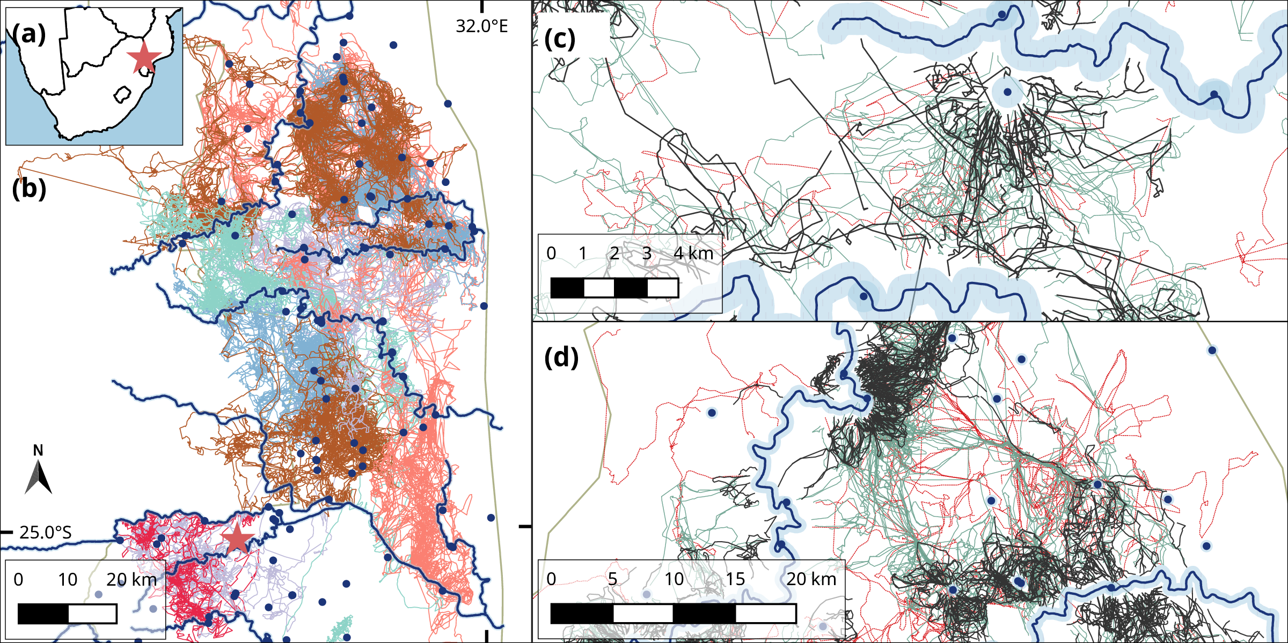

Fig. 1: (a) Study site in Kruger National Park, South Africa (red star), showing

(b) park boundary (dashed grey line), major rivers (solid blue lines), open waterholes (blue dots), and raw elephant tracks (coloured lines, n = 14).

(c) and (d) Insets showing 3 – 72-hour long track segments between water sources (blue dots and lines), coloured by duration class (12 – 24 hours: black lines, 24 – 48 hours: green, 48 – 72 hours: red). The 500m buffer from river and waterhole centres is shaded in blue.

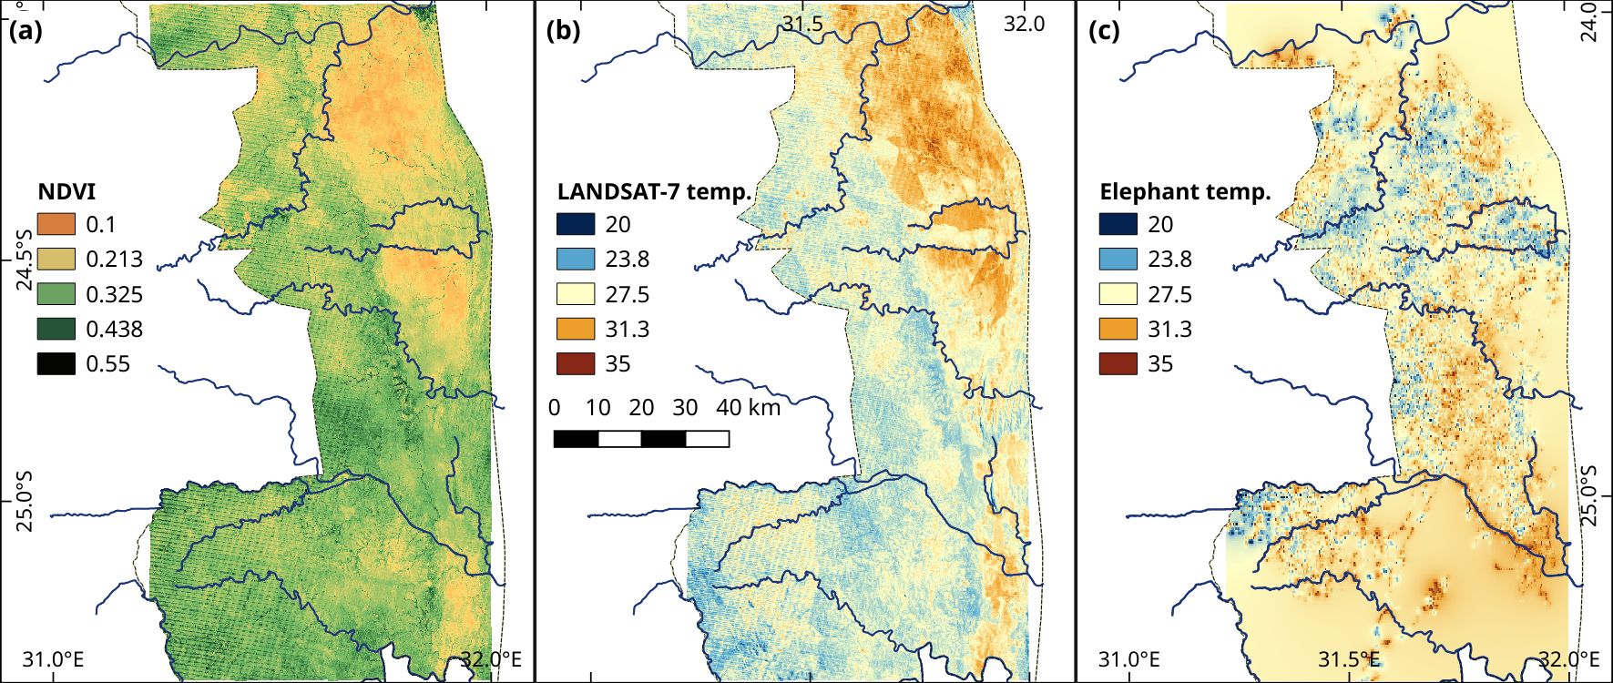r

Fig. 2: (a) Two year mean NDVI in Kruger National Park over the study period August 2007 – August 2009.

(b) LANDSAT-7 derived mean daytime temperature in Kruger NP over the study period, and

(c) Ambient temperature as reported by elephant-borne thermochrons over the study period.

Map (c) created as an inverse distance interpolation of values from elephant position and thermochron data, respectively

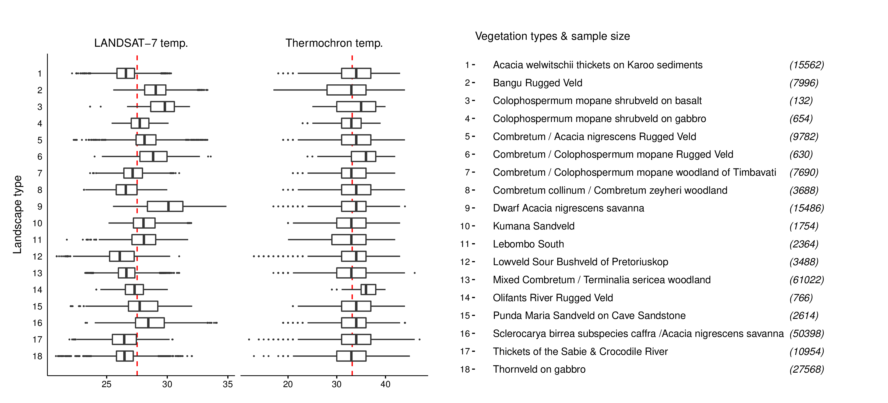

Fig. 3: Boxplots of the mean daytime temperature over the two-year long study period (August 2007 – August 2009) derived from LANDSAT-7, and the ambient daytime temperature reported by elephant-borne thermochrons over the the two-year study period, in each of 18 vegetation types reported in the data (right hand side). Numbers in brackets next to the vegetation types represent the number of elephant positions in each vegetation type. Data are not divided by season.

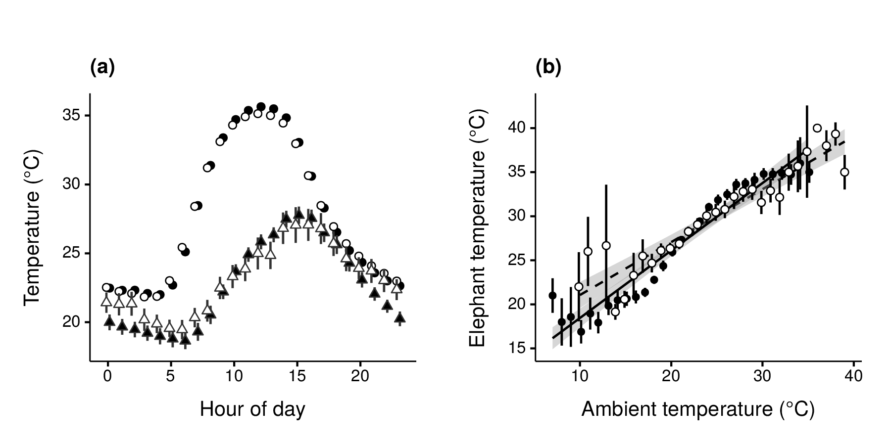

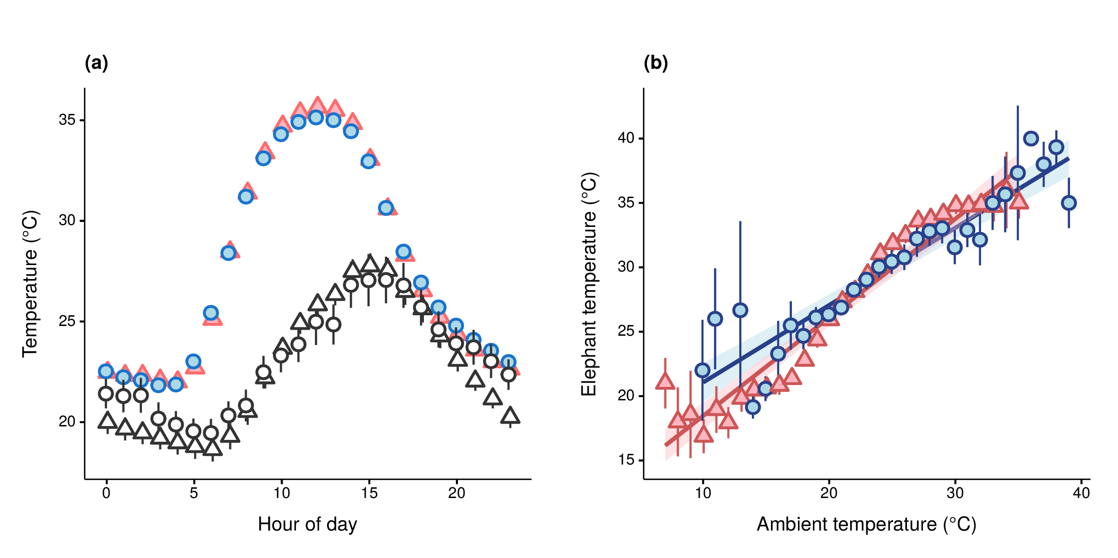  
Fig. 4: (a) Mean thermochron temperature (circles) and measured ambient temperature (triangles) at each hour of day in each season (cool-dry: open symbols, hot-wet: filled symbols) across the study period.

(b) GLM fits (lines) in each season (cool-dry: open circles & dashed lines, hot-wet: red triangles & lines). Vertical lineranges and shaded areas (coloured by season) indicate 95% confidence intervals at each point.

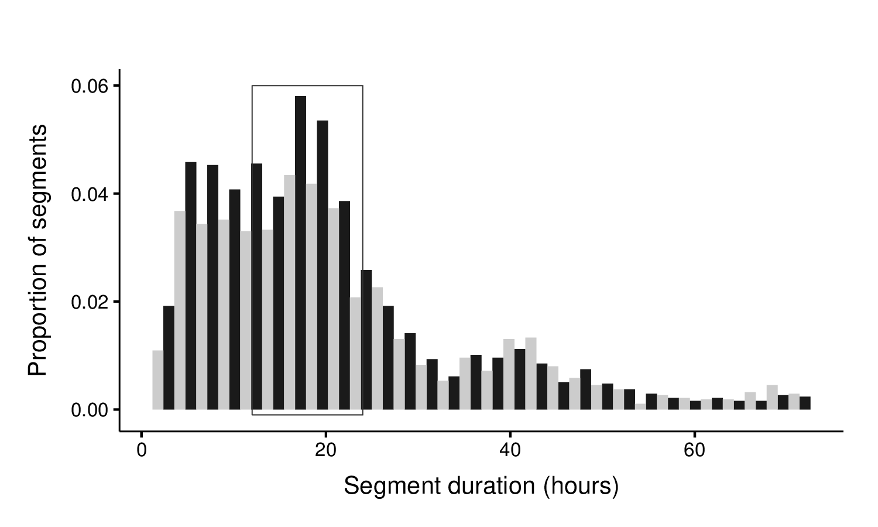



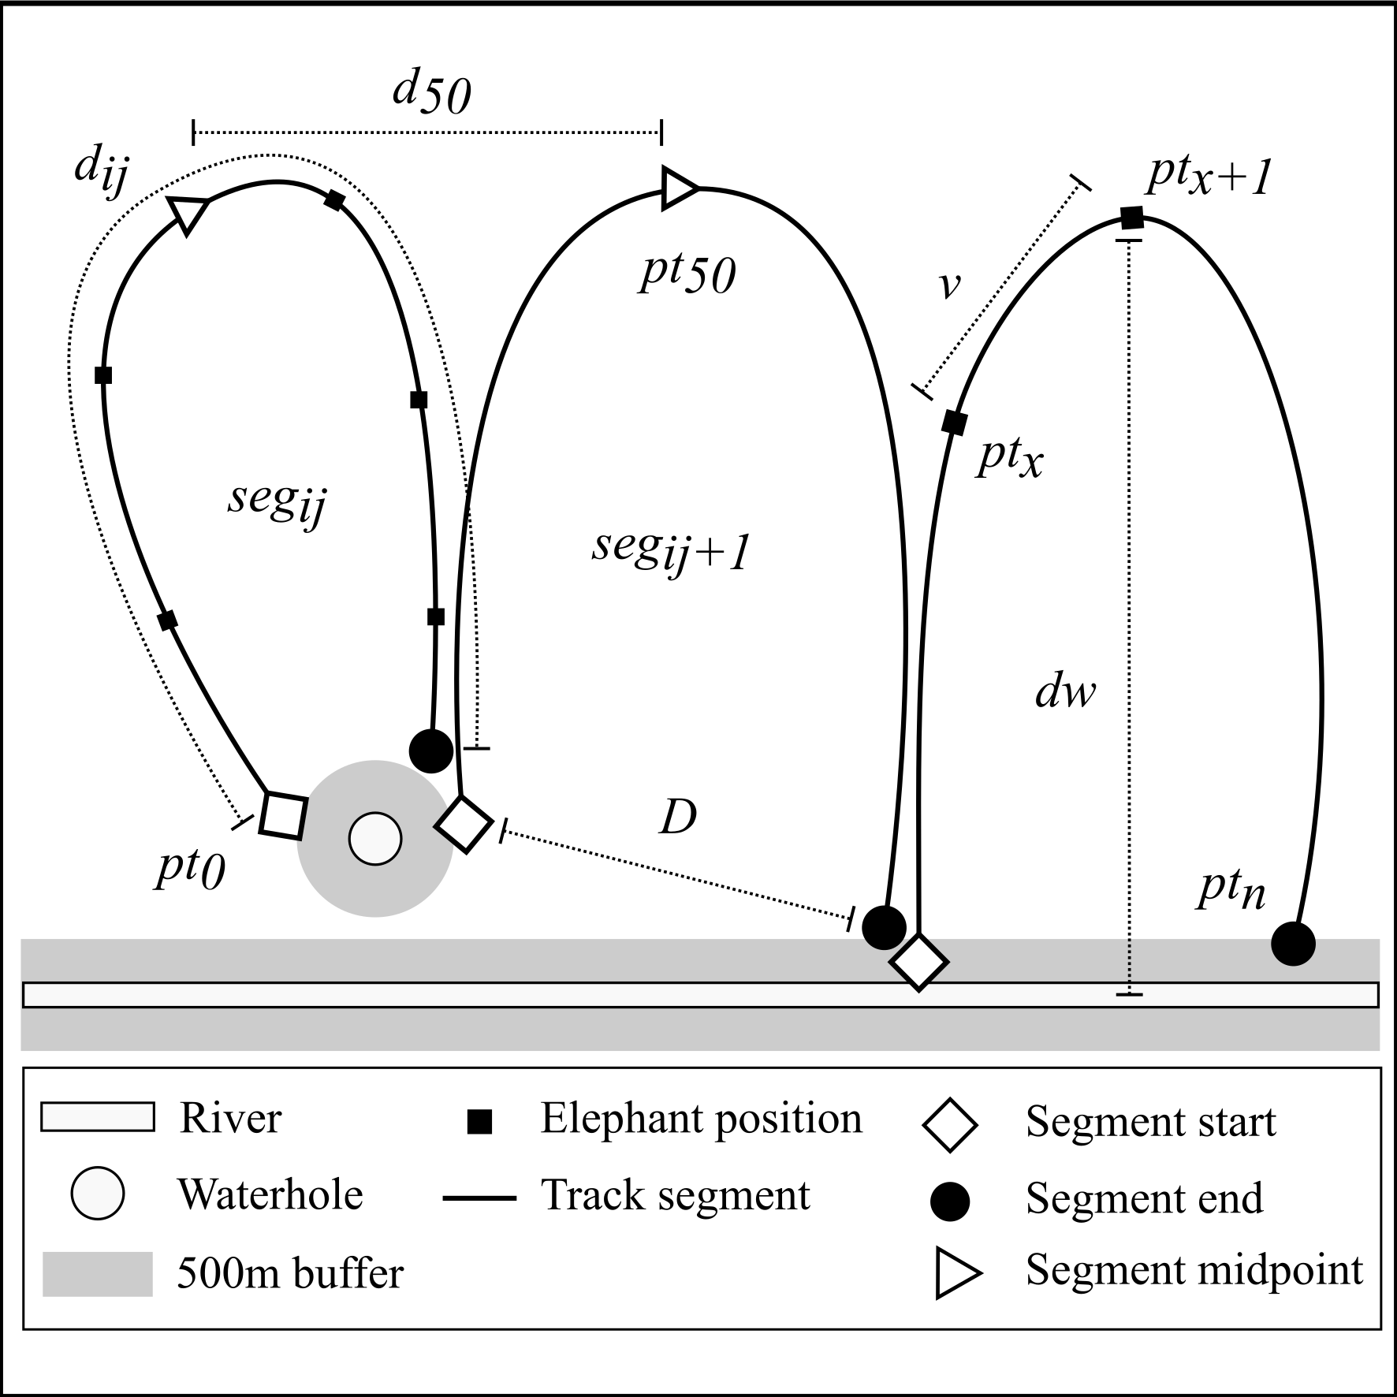

Fig. 5: Schematic of elephant track segments between water points. We collected elephant positions (filled squares, denoted by ptx) using GPS transmitters*. Positions within 500m (shaded grey area) of a water source (river: open rectangle, waterhole: open circle) were identified as water points.*

*For each individual elephant* i*, we identified track segments* j *(solid lines, denoted segij) as the path joining all positions chronologically between successive water points. Each segment began at a water point (open rhombi, pt0), and ended at the point immediately preceding the starting point of the next segment (filled circle, denoted by ptn).*

*We calculated the time-difference between each segment’s start and end points as the segment time (tseg), and identified the segment’s midpoint (open triangle, denoted pt50) as the elephant position when half the segment time had elapsed (tseg/2).*

*We computed the distance travelled between successive positions (ptx → ptx+1) in a segment as the steplength (denoted by v), and the sum of all v in a segment as the distance travelled along the segment (denoted dij). We calculated the displacement (linear distance, denoted D) between each segment’s start and end points, and the displacement (linear distance, denoted d50) between the midpoints of successive segments.*

*Finally, we obtained the linear distance from each elephant position to the nearest water source (denoted dw), and the thermochron temperature at each position (Tx).*

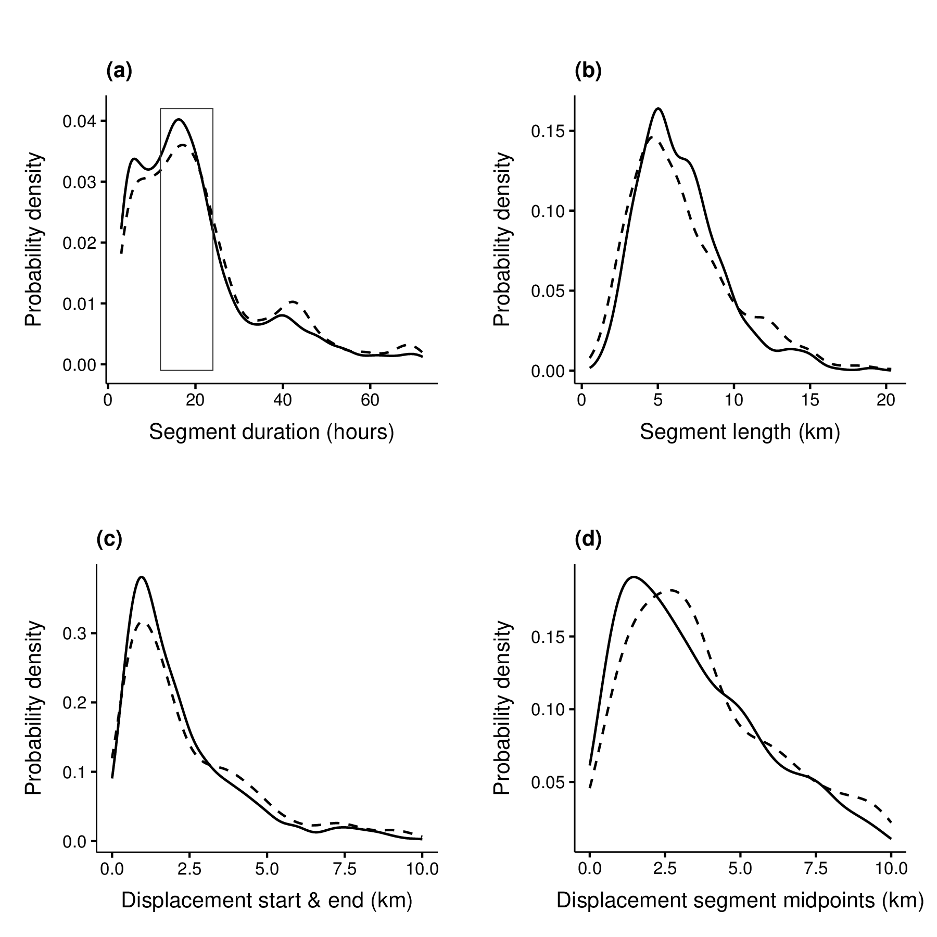

Fig. 6: (a) Probability density plot of segment durations (in hours) between water points. Lower and upper limits of segment durations in both seasons have been set at 3 and 72 hours, respectively. The rectangle denotes the peak representing segments of a duration between 12 and 24 hours, which were used for all further characterisation.

Probability density plots of (b) Actual distances travelled by elephants along 12 -- 24 hour track segments between water points, (c) Linear distances between start and end points of 12 – 24 hour track segments between water points, and (d) Linear distance between the midpoints (defined by temporal duration) of successive 12 – 24 hour segments in each season. Data are separated by season (cool-dry: dashed lines, hot-wet: solid lines).

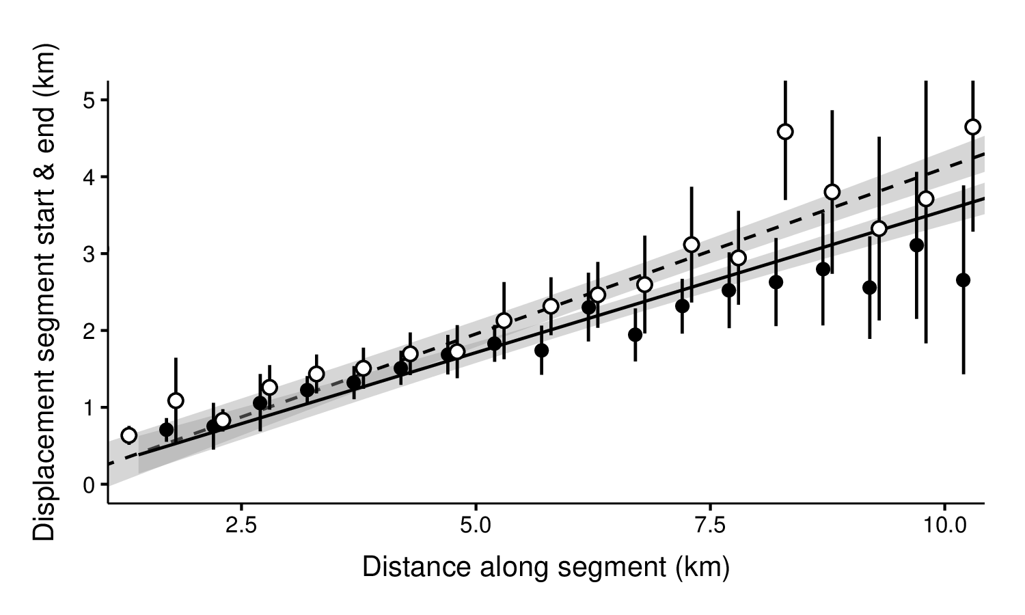Fig. 7: Displacement (linear distance) between the beginning and end of 12 – 24 hour segments between water points, as a function of the distance moved along the segment, in each season. Data were grouped and averaged in 500m increments of the distance along segments. GLM fit line for each season is shown. Seasons are represented by symbols and lines (cool-dry: open circles & dashed line, hot-wet: filled circles & solid line). Vertical lines represent 95% confidence intervals about each point.

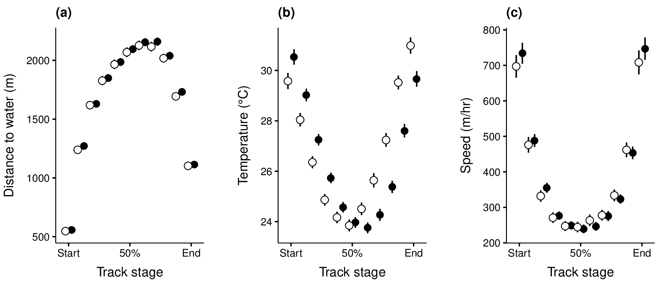

Fig. 8: Elephant movement variables along 12 – 24 hour track segments between water points at 10% intervals of segment duration (time):

(a) Minimum distance to water (in metres),

(b) Thermochron temperature, and

(c) Speed (in m/hr). Points are separated by season (cool-dry = open circles, hot-wet = filled circles), and offset from each other to avoid overlap. Vertical lineranges show 95% confidence intervals about each point.

Fig. 9: Elephant speed (points) at 2°C temperature intervals in each season (cool-dry: blue circles, hot-wet: red triangles). GAMM fit (lines), data error intervals (lineranges), and fit error intervals 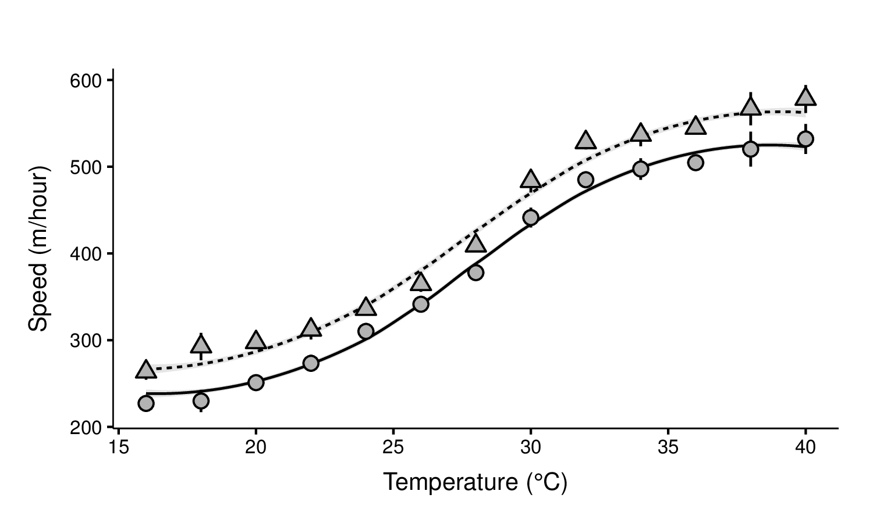(shaded areas) are shown.